**Database and Management System Lab**

NAME: PRIYANSHI VARSHNEY

ROLL NO: R2142230042

SAP_ID: 500119947

BATCH 2

B.TECH CSE, SEM-III

**EXPERIMENT 13**

**Title: To understand the concepts of PL/SQL programming.**

**Objective:** Students will be able to implement the basic concepts of Pl/SQL.

**1. Write a PL/SQL code to accept the value of A, B & C and display which is greater.**

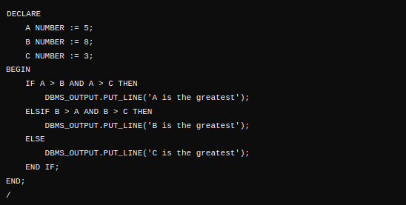



**2. Using PL/SQL Statements create a simple loop that displays the message “Welcome to PL/SQL Programming” 20 times.**

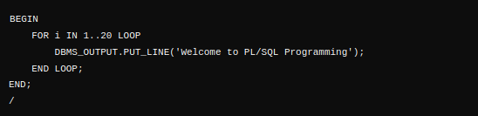

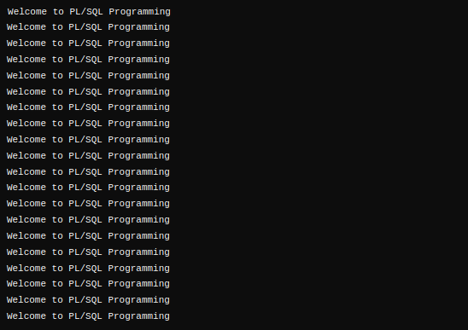

**3. PL/SQL Code to Find the Factorial of a Number**

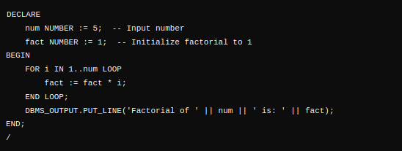



**4. PL/SQL Program to Generate Fibonacci Series**

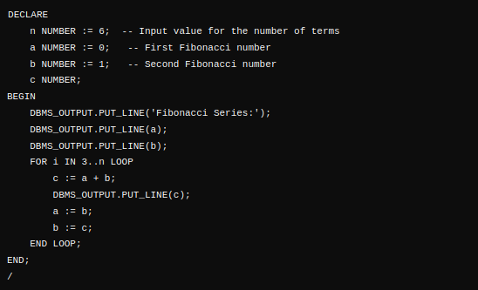

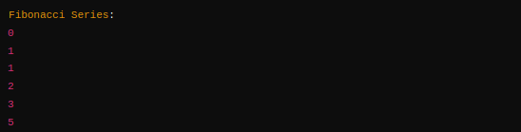

**5. PL/SQL Code to Find the Sum of First N Numbers**



